# **Spring Core – Load Country from Spring Configuration XML**

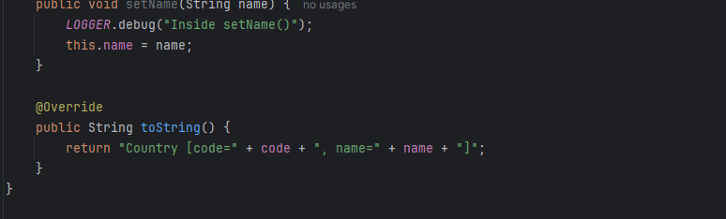

Country.java

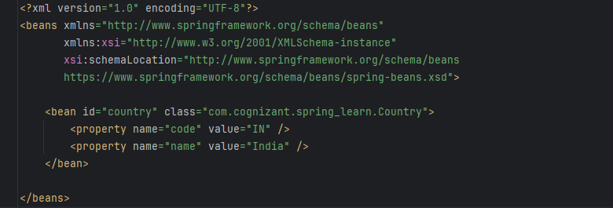

Country.xml

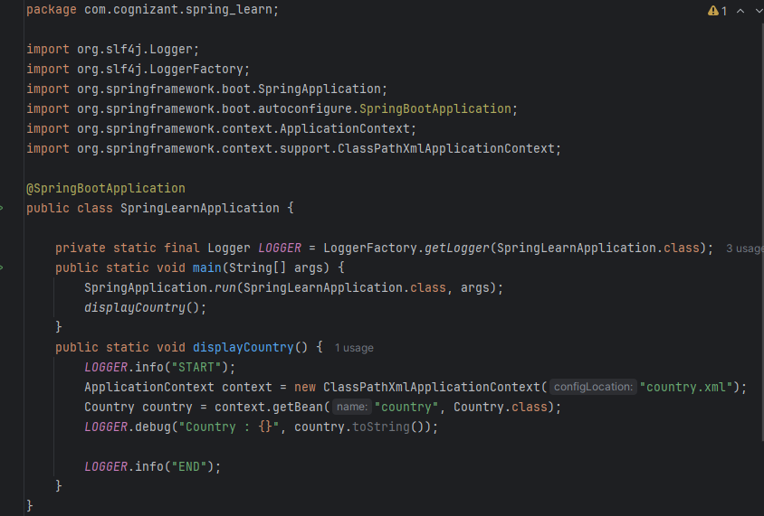

Output:

